
Faculty of Science

Course: CSCI 2020u – Software System Development & Integration
Component: Assignment
Weight: 10%
Deadline: March 5, 2020 (due by 11:59pm)

Collaboration Policy
You are permitted to work on this assignment in a team, and submit the results as a team. For this sort of assignment, with an open-ended component, the collaboration between multiple team members can be beneficial. Between groups, however, please limit the discussion to the level of general strategy (not code). Groups of size 2 are recommended. Larger groups will be considered with the proviso that the marker will mark your assignment with higher expectations. In any case, be sure that all members of the team fully understand all code, otherwise they will miss intended learning objectives, which may be a considerable disadvantage at exam time.

COMPLETED BY JUSTIN VOLCKMAR AND NATHANIEL ARMOGAN

How to Submit
You will maintain a git repository for this assignment, which is a public repository. To submit the assignment, create a single file ‘README.txt’ that contains instructions on how to download, compile, and run your codes for each question. A .zip, .7z, or .rar file will not be acceptable. Also submit this word file (once you complete) into related drop box on Blackboard before deadline.

Note: Comments are mandatory. Failure to properly document your program will result in a deduction on the marks you receive for this (and any other) assignment.

Remember:
You need to complete this file and submit it in related drop box on Blackboard, in addition to uploading your codes in your git repository, before deadline.

CLICK HERE
https://github.com/justinvolckmar/Assignment

Question 1: Displaying Three Cards

Your Code:
https://github.com/justinvolckmar/Assignment/blob/master/src/question1/Cards.java

Screen shots:
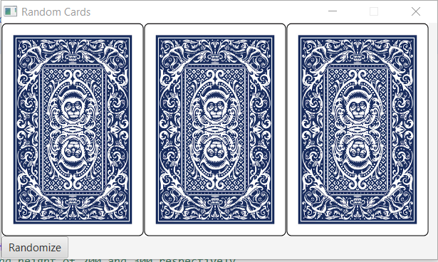
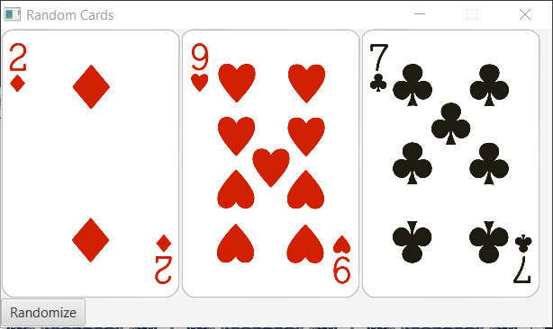

Question 2: Investment-Value calculator

Your Code:
https://github.com/justinvolckmar/Assignment/blob/master/src/question2/Investment.fxml

Screen shots:
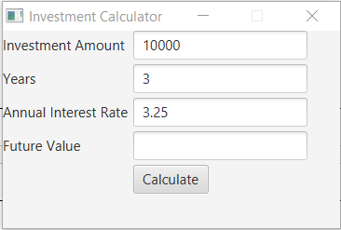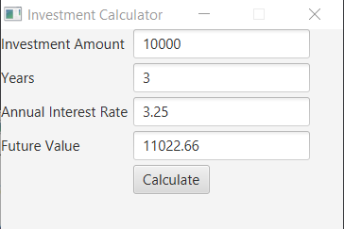

Question 3: Dragging Points on a Circle

Your Code:
https://github.com/justinvolckmar/Assignment/blob/master/src/question3/Circles.java

Screen shots:
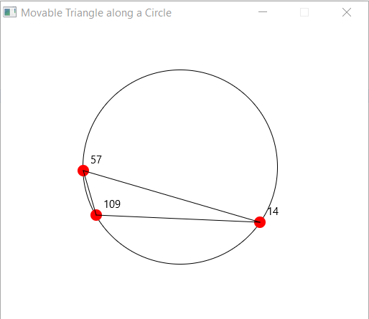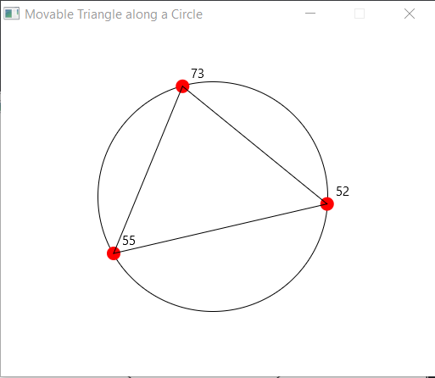
Question 4: Histogram

Your Code:
https://github.com/justinvolckmar/Assignment/blob/master/src/question4/Histogram.java
Screen shots:
